**Experiment no. 8 : To Study Project Scheduling using Gantt Chart in Click Up.**

**Gantt Chart**

A Gantt Chart is a visual project management tool used for scheduling tasks over time. It helps teams plan, track, and manage projects by displaying tasks, deadlines, dependencies, and progress in a timeline format.

**Gantt Charts in ClickUp**

ClickUp provides an intuitive Gantt Chart feature that allows teams to:

* Plan Projects Efficiently → Define timelines and dependencies.
* Track Progress → Monitor task completion visually.
* Adjust Schedules Easily → Drag-and-drop tasks to reschedule.
* Enhance Collaboration → Assign tasks and track workload.

**Steps to Create a Gantt Chart in ClickUp**

1. Set Up a ClickUp Workspace

1. Sign in to ClickUp or create an account.
2. Create a new project or choose an existing one.

2. Add Tasks and Define Milestones

1. Navigate to the List View and create tasks.
2. Set start and due dates for each task.
3. Define milestones for key project checkpoints.

3. Open the Gantt Chart View

1. Click on the View button and select Gantt Chart.
2. The tasks appear in a timeline format based on their start and due dates.

4. Set Dependencies

1. Click on a task and drag the dependency line to another task.
2. Choose from four types of dependencies:
   * Finish-to-Start (FS) → Task A must finish before Task B starts.
   * Start-to-Start (SS) → Task A and B start at the same time.
   * Finish-to-Finish (FF) → Task A and B finish together.
   * Start-to-Finish (SF) → Task A must start before Task B finishes.

5. Monitor and Adjust the Project Schedule

1. Drag tasks to reschedule them if needed.
2. Use color codes to track task status (e.g., In Progress, Completed, Delayed).
3. Enable auto-scheduling to adjust dependencies dynamically.

**Benefits of Using ClickUp Gantt Charts**

* Real-Time Tracking → Monitor project timelines effectively.
* Improved Team Coordination → Assign tasks and manage workload.
* Flexibility → Easily reschedule tasks and update dependencies.
* Customizable Views → Adjust settings to fit your project needs.

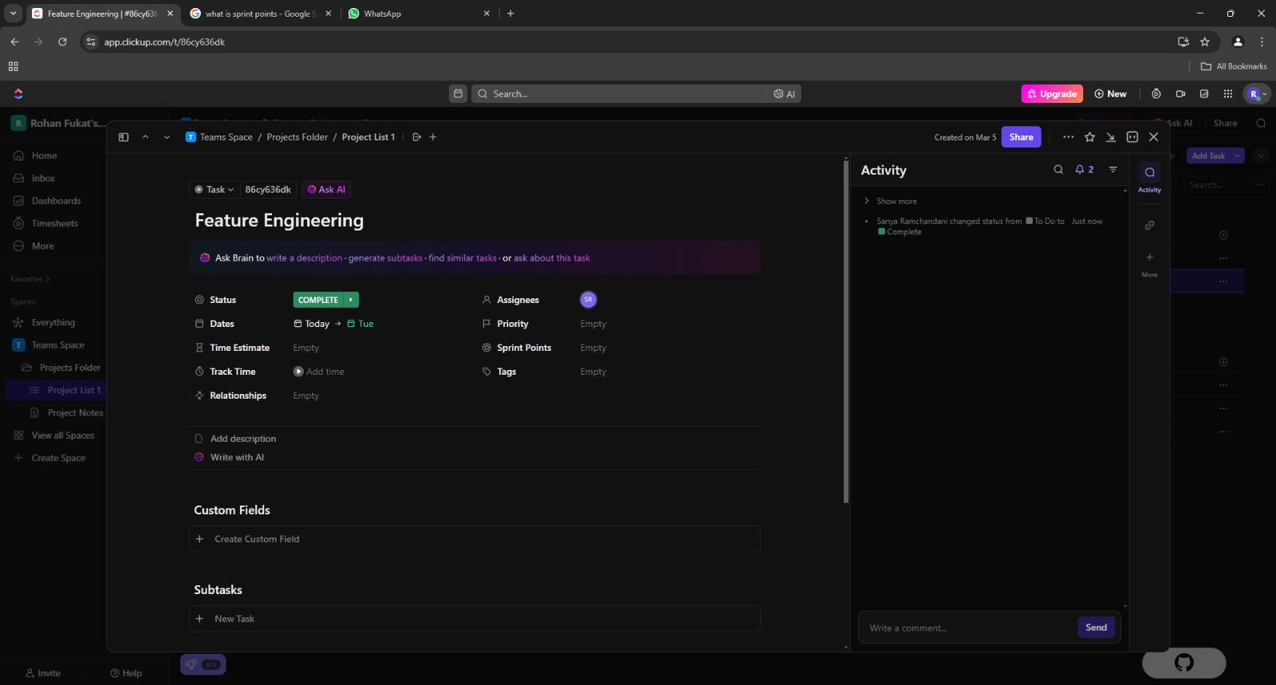

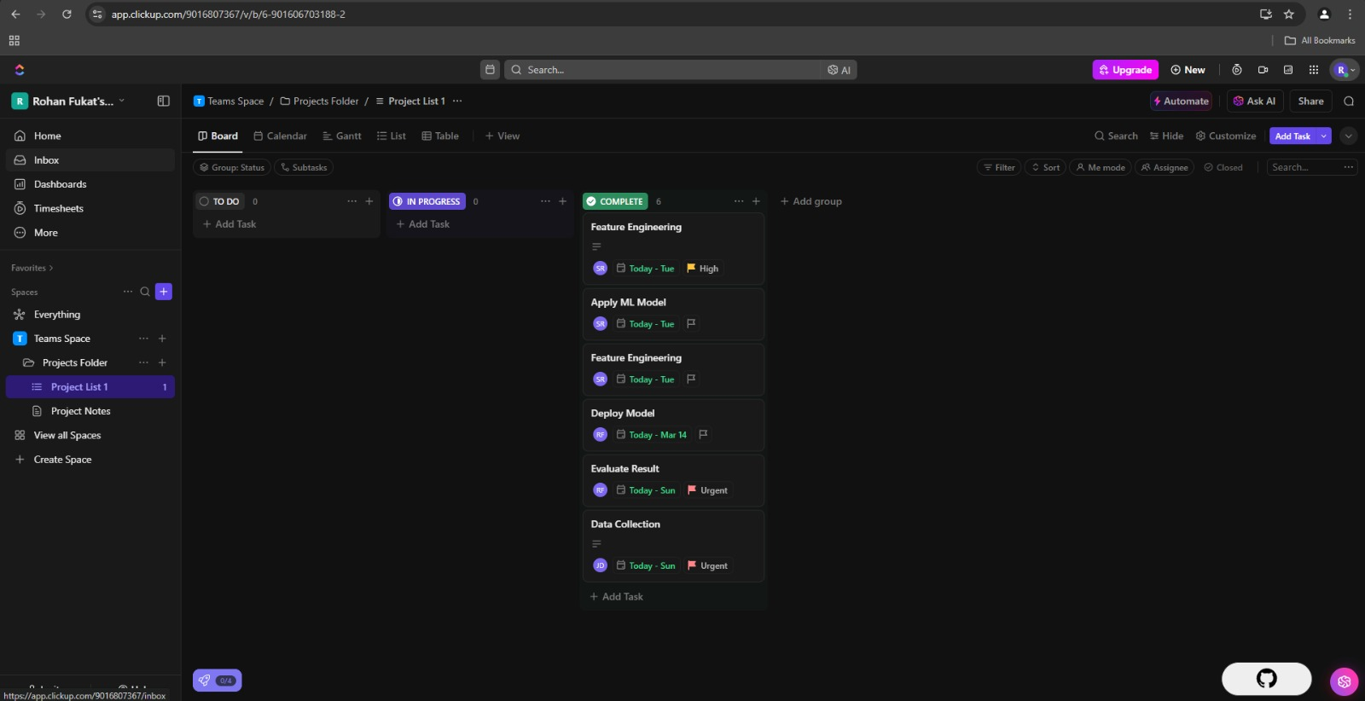

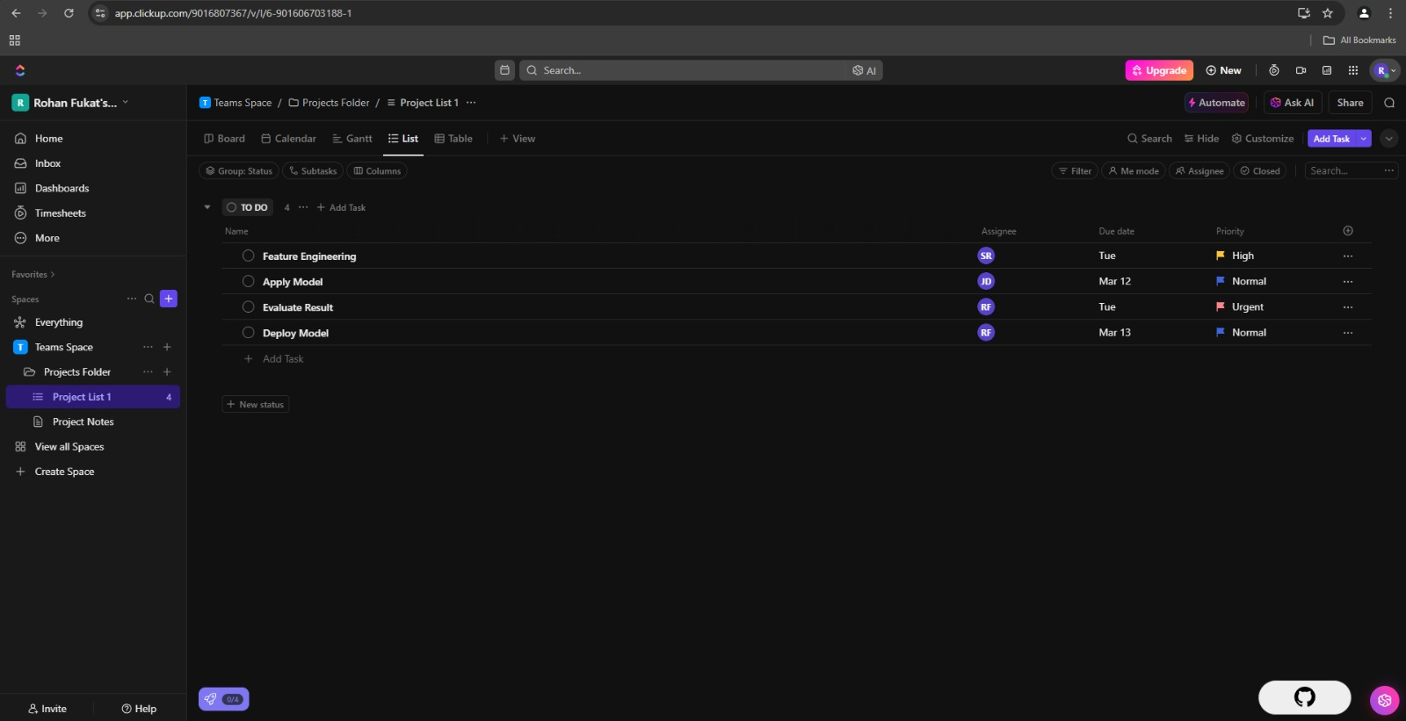

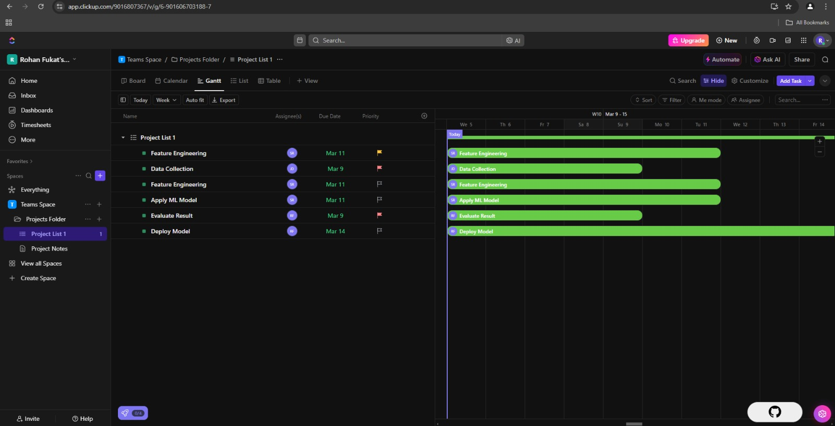

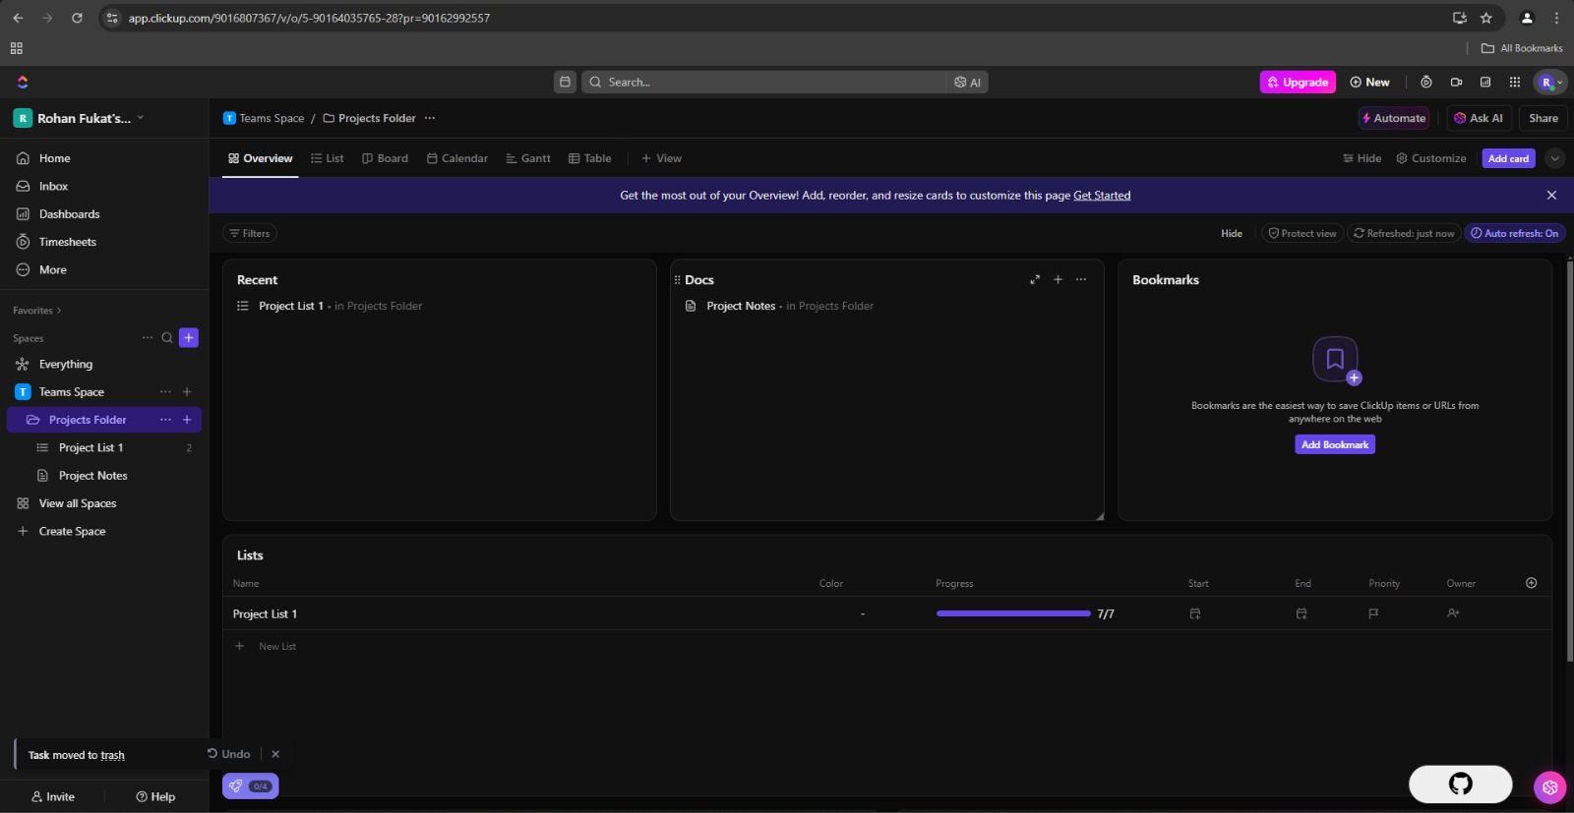

**Conclusion :** Thus, we have successfully studied project scheduling using Gantt Chart in Click Up.